

EXPRESS AUTOCARE OPS
Workshop ERP
& Customer App
Plan & process spec — walk-in to delivery on EA Mobile, back office on EA Admin, and the EA Customer App for every car owner.
Version: 1.0
Date: 12 October 2026
Prepared for: Joel D'Souza, Express Autocare
Reference: October 2026 workbook; Service Plan Masters; EA plan activity sheets

Contents
1. Overview
2. Roles & first screens
3. Walk-in & intake
4. Service work
5. Estimate & customer approval
6. Billing, payment & gate pass
7. Delivery & post-delivery
8. EA Customer App
9. Job status flow
10. Back office (EA Admin)
11. Calculations & month-on-month rules
12. Data model
13. Cross-cutting capabilities
14. Tech stack & distribution
15. Roadmap, effort & running costs
16. Open decisions

1. Overview
Express Autocare Ops is a complete workshop ERP with a customer app. Staff work on a mobile floor app, the owner and back office use a web console, and customers use the Express Autocare app — with WhatsApp as the fallback for anyone who hasn't installed it. It replaces the printed job cards, hand-forwarded WhatsApp photos and the monthly Excel files (October 2026 workbook onwards).
This is the process spec; each step is tagged with the surface that owns it:
- EA Mobile — workshop floor app on staff phones (Service Advisor, Technician, Driver / Home-service Technician, Billing Executive, Workshop Manager / Owner).
- EA Admin (Web) — desktop console for the owner, accounts, parts and HR: masters, plans, stock, GST, payroll, P&L and the dashboard.
- WhatsApp Agent — customer channel for walk-in confirmation, OTPs, task photos and videos, estimates and approvals, invoices, payment receipts, NPS and Google review nudges, and service reminders.
- EA Customer App — Android and iPhone app for customers: live job tracking, estimate approvals, service history and reports, bills and payments, and reminders for service, PUC, insurance and other renewals (section 8).
Modules at a glance
Module | Surface | Covers
Front office | EA Mobile | Walk-in registration, intake, estimates, customer approvals
Workshop floor | EA Mobile | Digital job cards by plan and car class, activity points, photo / video evidence, parts requests, trial drive, wash, QA
Billing & payments | EA Mobile + EA Admin | GST invoices, payments, gate pass, credit notes
Spare parts inventory | EA Mobile + EA Admin | Catalogue, stock by location, plan kits, purchase bills, reorder
Accounts & GST | EA Admin | Income, cash and bank expenses, cash drawer, staff GPay, accruals, GST registers and returns data
HR & payroll | EA Mobile + EA Admin | Staff records, attendance, leave, advances, incentives, salary run, PF / ESI / PT / TDS
Dashboard & month close | EA Mobile + EA Admin | Owner KPIs, P&L, trends, month lock and carry-forward
CRM & reminders | EA Admin + EA Customer App + WhatsApp | Service history, next-service, PUC and insurance reminders, NPS, reviews, offers
Customer app | EA Customer App | Everything the customer sees and does
Items not yet in scope are flagged Planned / Not built.

2. Roles & first screens
Every role lands on a home screen of buckets that tell them what to do next; profit, salaries and parts cost are visible only to the owner and the accountant.
Role | Surface | First screen
Workshop Manager / Owner | EA Mobile + EA Admin | Owner Home — today's KPIs (cars in, revenue, collected, pending), Needs Attention, Awaiting Approval, Awaiting Payment, SLA Breach; acts on every job
Service Advisor / Asst SA | EA Mobile | Advisor Home — REGISTER WALK-IN, Intake Pending, Awaiting Approval, Additional Jobs, Ready for Delivery
Technician / Detailer | EA Mobile | Technician Home — Active Work, Needs Intake Checklist, Awaiting Advisor, Awaiting Parts, Verification & Wash, QA Queue, Completed Today
Head Technician / Supervisor | EA Mobile | Technician Home + Trial Drive and QA queues
Driver / Home-service Technician | EA Mobile | Driver Home — Now, Next Pickups / Home Visits, Deliveries Ready, Completed Today
Billing Executive | EA Mobile | Billing Home — Collected Today, Pending Collection, Need Invoice, Gate Pass Issued — Awaiting Payment
Store / Parts | EA Mobile + EA Admin | Parts Requests queue on mobile; stock-in, purchase bills and reorder on EA Admin
Accountant / CA | EA Admin (read-only) | Month P&L, GST registers and returns data, cash and bank books
Customer Experience Executive | WhatsApp Agent + EA Admin | Planned / Not built on mobile: NPS follow-ups, review screenshots, advised-work reminders
Body Shop Coordinator / Technician | — | Planned / Not built
Customer | EA Customer App (WhatsApp fallback) | My Garage — live job, approvals needed, upcoming reminders (service, PUC, insurance), last bill, Request service
Note: There is no separate receptionist role. Front-desk staff log in as Service Advisor or Asst SA and use the walk-in screen as the single entry point for every job.

3. Walk-in & intake
Every job starts on the walk-in screen. Phone, WhatsApp and customer-app service requests all land in the advisor's queue and are registered as a walk-in, with a pickup or home-visit slot when the car is not at the workshop.

3.1 Walk-in registration (EA Mobile)
- Advisor Home → REGISTER WALK-IN opens a four-step form: Customer → Vehicle → Service → Review.
- Customer by mobile number; existing customers and their cars are pulled up with past visits and advised work.
- Vehicle: reg no, make / model / year / fuel (RTO lookup auto-fill is Planned / Not built), and car class — Hatchback, Prem. Hatch / Sedan / Compact SUV, SUV / MUV, Premium SUV, or Premium Luxury Class 1–3.
- Service: EA plan (Refresh, Essentials, Pro, 360, Elite), oil grade, or custom repair; location Godrej, NX or Home; mode Drive-in, Pickup & drop, or Home service with a slot.
- Submit creates or updates the customer, de-dupes the vehicle, opens a JobCard at INTAKE_PENDING (or PICKUP_SCHEDULED / HOME_VISIT_SCHEDULED) and fires the WhatsApp confirmation.

3.2 Pickup & home service (Driver / Home-service Technician)
- Driver taps START on a Next Pickups card; status → PICKUP_EN_ROUTE; map deep-link to Google Maps or Apple Maps.
- Four vehicle photos are required (front, rear, left, right) before the OTP can be submitted.
- Customer reads the 6-digit OTP from WhatsApp; on verify, status → VEHICLE_COLLECTED.
- Home service follows the same START → photos → OTP steps, then the technician works the plan checklist on site; workshop-only items (body wash, wheel alignment and balancing) are hidden.

3.3 Intake (EA Mobile)
- Advisor opens the JobCard and completes the intake details: odometer, fuel level and the customer's complaints in their words; assigns a Technician and a Bay. Status INTAKE_PENDING → INTAKE_IN_PROGRESS.
- Technician runs the intake checklist with mandatory photo rows — registration plate, exterior walk-around (existing dents and scratches), interior, instrument cluster.
- A pre-work check of the reported issues is part of intake, not a separate trial drive.

4. Service work
The printed job card is replaced by the plan's activity points for that car class, driven from the plan sheets the owner maintains on EA Admin.

4.1 Plan & sections (EA Mobile)
- Activity points come from the plan × car class template (Refresh 18, Essentials 25, Pro 45, 360 70, Elite 80 points).
- Sections follow the plan sheets: Engine & Fluids; Cabin, Lights & Electricals; Suspension, Wheels & Brakes; Road Test & Final Checks; Cleaning, Interior and Exterior Detailing. Selecting one section locks the others until it is complete.
- Per-task flags from the plan sheet: N/A, needs-replacement, media-required, reading (e.g. brake pad mm, battery load test), home-service-allowed.

4.2 Technician timer
- The timer starts automatically when the technician opens a job in a work status; pause and resume from the clock at the top. No manual START WORK tap.
- Time per job and per section feeds technician productivity and incentive reports.

4.3 Per-task capture
- A media-required task asks for a photo or a video (up to 60 s) before Done is enabled.
- The customer gets task updates with the photos and videos on WhatsApp, batched every few minutes rather than one message per task.
- An off-plan finding raises an Additional Job with photo or video and a suggested part or labour; the advisor sees it under Needs Attention and sends an add-on estimate (section 5). Status → AWAITING_APPROVAL until the customer answers.

4.4 Parts from stock
- Plan kits (oil litres, oil filter, consumables, AC filter, detailing supplies) are issued against the JobCard in one step by car class and plan.
- Other parts: the technician raises a parts request (urgency, photo of the failed part, description); Store issues from stock or orders it. Status → AWAITING_PARTS while it is out.
- Issued parts are costed at weighted-average cost, so each job's true margin is known.

4.5 Trial drive & wash
- When every task is Done or N/A, the Head Technician runs the post-work trial drive and records observations; status POST_WORK_TRIAL → WASH_PENDING.
- Wash is in-house or third party; tracked in the Verification & Wash bucket. Home-service jobs skip the wash.

4.6 QA challenge
- The system picks 3 random activity points; the advisor or Head Technician photographs each within a 15-second countdown per item.
- A failed point reopens the job; a pass moves status → READY_FOR_DELIVERY.

5. Estimate & customer approval
No work starts and no extra work is done without the customer's recorded approval in the customer app or on WhatsApp.
- Base estimate (at intake): the advisor drafts it on EA Mobile; the plan price comes from Service Plan Masters for that plan, car class and oil grade, plus any custom-repair lines.
- Line types: Plan, Labour, Parts, Detailing, Third-party (alignment & balancing, AC, machining). Wheel alignment & balancing is an add-on at ₹1,000; balancing weights at actuals.
- GST per line (0 / 5 / 12 / 18 / 28) with an inclusive-vs-exclusive toggle, so vendor quotes with tax built in are not double-counted.
- Send pushes the estimate to the customer app (and a WhatsApp link for customers without it): the customer reviews the lines, photos and videos and approves or declines each line; full, partial or no approval is recorded back into the JobCard, line by line.
- Add-on estimates for Additional Jobs follow the same path; declined lines are kept as advised work on the vehicle and reminded at the next visit.
- The advisor can revise and resend after a phone call if the customer changes their mind; every version is kept.
- On approval, status → WORK_IN_PROGRESS (base) or back to the job's previous work status (add-on).
Planned / Not built: voice-to-text remarks from the customer, and an advisor approval-on-call rule below a set amount (see Open decisions).
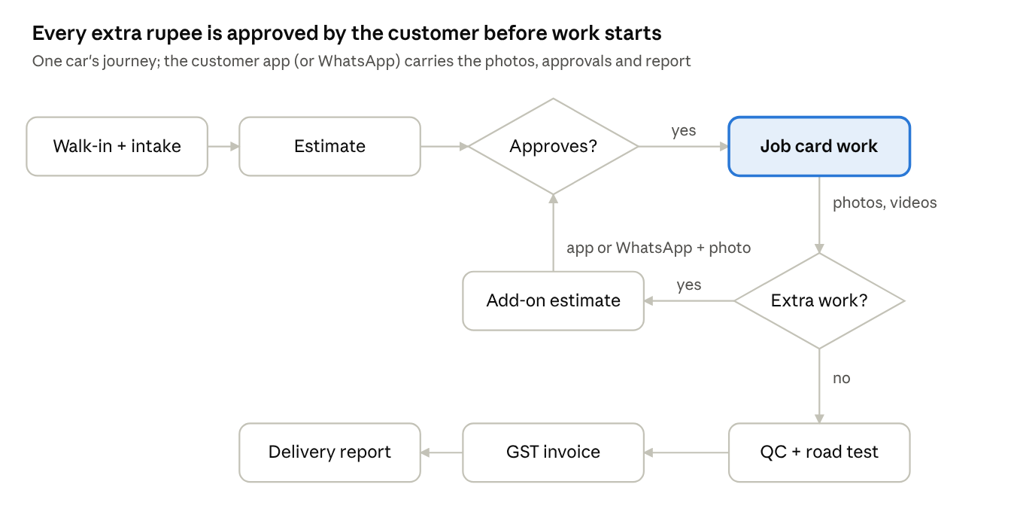
one car's journey · walk-in to delivery
Extra work found during the job loops back through the customer before it is done; anything declined is kept as advised work and reminded at the next visit.

6. Billing, payment & gate pass
The approved estimate becomes one GST tax invoice from Express Autocare to the customer, and the car leaves only against a gate pass issued on full payment.
- Billing Home shows Collected Today, Pending Collection, Need Invoice (READY_FOR_DELIVERY) and Gate Pass Issued — Awaiting Payment.
- Invoice: approved base and add-on lines convert in one tap; parts carry HSN codes and labour / service carries SAC codes from masters; CGST + SGST or IGST by place of supply; customer GSTIN for business customers. One series per division (Service, Body Shop), reset every 1 April, no gaps. Status → INVOICED.
- Payment methods: Cash, UPI / QR, Card / payment link, NEFT, Debit / Cheque, and Staff GPay (logged against the staff member). Reference number required for everything except cash; part-payments allowed.
- Each payment writes a Payment row and lands in the day's income and the cash drawer or bank book automatically — the Income sheet is never typed again.
- Gate pass: issues automatically when the invoice is fully paid; status → GATE_PASS_GENERATED. No payment ⇒ no gate pass ⇒ no delivery.
- Corrections: an issued invoice is never edited; credit or debit notes are raised against it.
- The invoice PDF and payment receipt go to the customer on WhatsApp.
Planned / Not built: owner override of the no-pay-no-gate-pass rule (credit customers), split insurance billing (insurer's share vs customer's share), and e-invoicing through a GST Suvidha Provider if turnover crosses the threshold — confirm applicability with the CA.

7. Delivery & post-delivery
Delivery closes the job with proof, and the visit feeds the next one: the service report, advised work and next-service date go to the customer the same day.

7.1 Delivery
- Counter collection: customer collects at the workshop against the gate pass; status → DELIVERED.
- Drop: driver taps DELIVER on a Deliveries Ready card; four parked-car photos at the customer's address are required; delivery OTP from WhatsApp; on verify, status → DELIVERED.
- Home service: the technician closes with completion photos and the OTP at the customer's place.
- On delivery the customer receives the service report on WhatsApp: every activity point done, photos and videos, readings, and advised work not done.

7.2 Post-delivery
- Day-3 NPS and Google review nudge through the WhatsApp Agent; low scores raise a follow-up for the owner.
- Next service: due date and KMs are set by the plan — Refresh: 4 months or +2,000 km; Essentials, Pro, 360, Elite: 9 months or +7,500 km. Reminders go out on WhatsApp before the date.
- Advised work not done is reminded with the next-service message.
Planned / Not built: Customer Experience Executive screens on EA Mobile (review screenshot upload, follow-up calls log).

8. EA Customer App
The customer app puts everything a car owner expects from their workshop in one place: what is happening to the car right now, what was done and billed before, and what falls due next — service, PUC, insurance and other renewals. It runs on the same data as the workshop, so nothing is entered twice, and every message it carries also goes on WhatsApp for customers without the app.

8.1 Features
Area | What the customer can do
Login & profile | Sign in with mobile number + OTP; name, addresses for pickup / home service, GSTIN for business customers; add family members to share a car
My garage | All their cars with photo, reg no, model, fuel, car class, odometer and last service; add a car by reg no
Live job tracker | Status of the car in the workshop (received, inspected, approval needed, in progress, QC, ready, delivered), assigned advisor, expected delivery time, task photos and videos as they arrive
Estimates & approvals | Open the estimate with photos and videos of each finding; approve or decline line by line; see the revised total before work continues
Service history | Every visit by date and odometer: plan, activity points done, readings, parts replaced (brand, part no, warranty), technician, photos and the full service report
Bills & payments | GST invoices, credit notes and receipts as PDF; pay pending amounts by UPI or card; download for company reimbursement or insurance claims
Reminders | Next service (date or KMs, whichever first), PUC expiry, insurance renewal, advised work not done, tyre rotation, battery and part warranties, plan renewal — see 8.2
Documents wallet | Upload or capture RC, insurance policy, PUC certificate, extended warranty and FASTag details; expiry dates read from the upload or entered once
Request service | Ask for a service, repair, pickup or home visit with a preferred slot and photos of the issue; it lands in the advisor's queue and becomes a walk-in JobCard when the advisor confirms (walk-in stays the only way a job is opened)
Plans & prices | EA plans (Refresh, Essentials, Pro, 360, Elite) with activity points and prices for the customer's own car class and oil grade; add-ons such as wheel alignment & balancing
Emergency help | One-tap call for breakdown, battery jump-start or towing; share live location with the workshop
Insurance claim help | Start a claim: photos, policy details, preferred surveyor slot; track claim status on the job
Feedback & rewards | Rate each visit, Google review nudge, referral code and rewards, offers for their car
Support | Call or WhatsApp the advisor, workshop locations (Godrej, NX), opening hours and directions

8.2 Reminder rules
Reminder | Source of the due date | When it fires
Next service | Plan rule: Refresh 4 months / +2,000 km; Essentials, Pro, 360, Elite 9 months / +7,500 km; KMs projected from the car's average running | 30, 7 and 1 day before; again if missed
PUC | Expiry date on the PUC certificate (wallet or captured at walk-in) | 15, 7 and 1 day before expiry
Insurance | Policy end date (wallet or captured at walk-in) | 30, 15, 7 and 1 day before; renewal quote on request
Advised work | Declined estimate lines | With the next-service reminder, or after 30 days for safety items (brakes, tyres)
Tyre rotation / alignment | KMs since last done | At the plan's interval
Warranty | Part warranty from the invoice line (battery, tyres, parts) | 30 days before expiry
Custom | Customer-set reminder (e.g. FASTag top-up, fitness certificate) | On the date set
Each reminder goes by app push first and WhatsApp if the app is not installed or the push is not opened within a day. Every reminder has a one-tap Request service.

8.3 What the workshop controls (EA Admin)
- Reminder templates, timings and channels; offers and plan prices shown to customers.
- Which photos and videos are customer-visible (internal-only photos stay internal).
- Campaigns to a segment (e.g. all cars whose PUC expires this month, all SUVs due for service).
- App content: workshop locations, hours, emergency numbers, FAQs.
Planned / Not built: in-app chat with the advisor (WhatsApp covers it), online parts shop, and fetching PUC or insurance status automatically from government or insurer systems — dates come from the customer's documents until an integration is chosen.

9. Job status flow
Every JobCard moves through one set of statuses, which drive each role's home-screen buckets, the customer's WhatsApp milestones and the SLA timers.
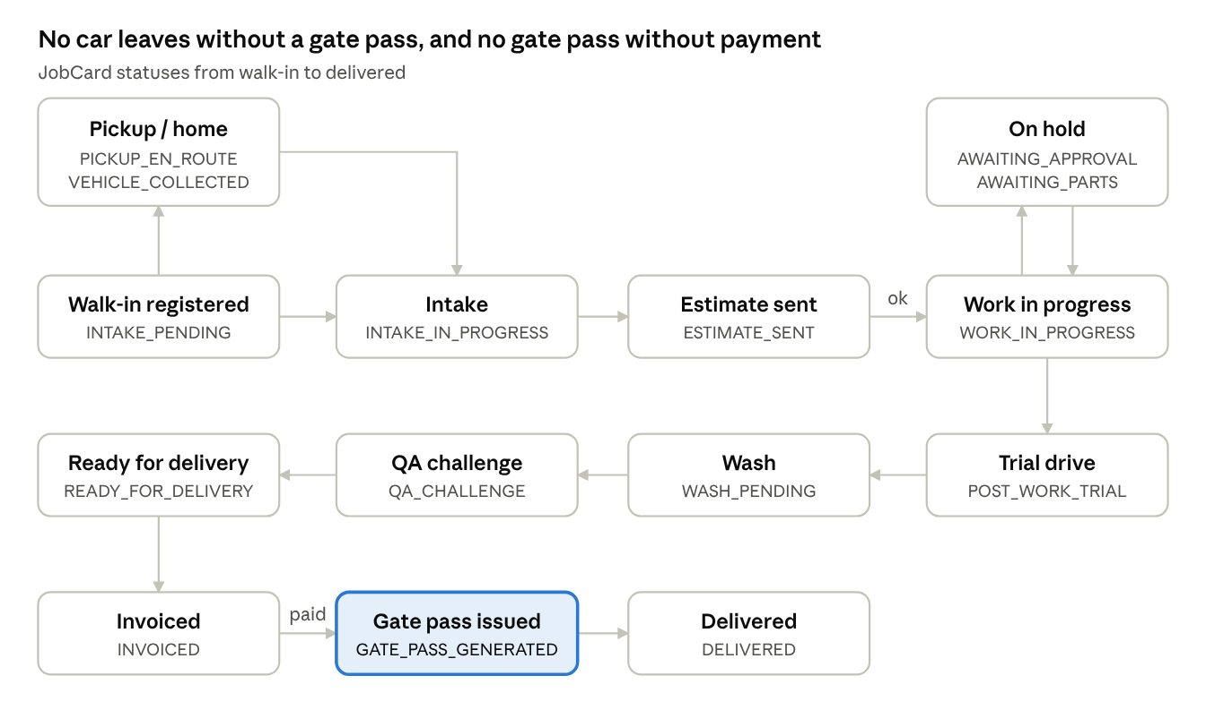
JobCard status flow · walk-in to delivered
Pickup and home-service jobs start at PICKUP_SCHEDULED or HOME_VISIT_SCHEDULED before intake. Work goes on hold while an add-on waits for the customer or a part waits for the store; a failed QA point returns the job to work in progress.

10. Back office (EA Admin)
The floor app produces the transactions; EA Admin turns them into books, GST, stock, payroll and a monthly P&L — everything the October 2026 workbook does today, with months linked.
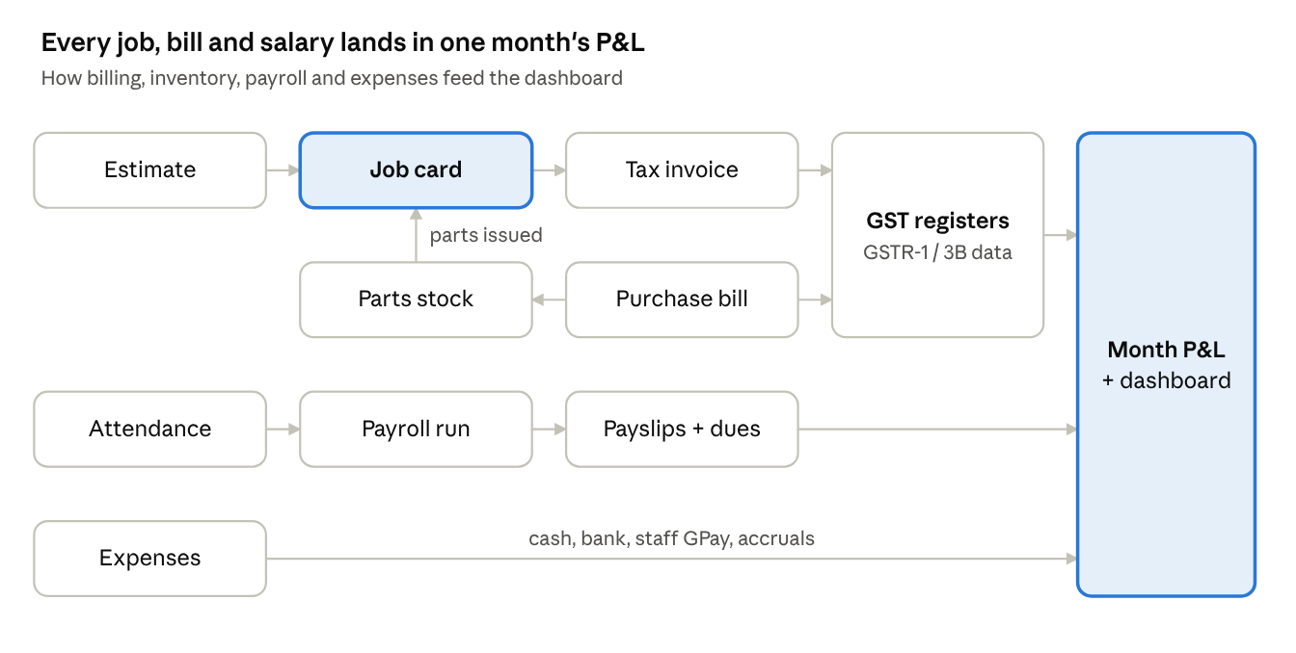
module map · billing, inventory, payroll, expenses
One purchase bill feeds both stock and input GST; parts issued to a JobCard set its true cost; technician incentives are calculated from the JobCards they closed.

10.1 Accounts & daily cash
- Income posts itself from invoices and payments (by location: Godrej, NX, Home; by mode: cash, card, UPI, debit / cheque, staff GPay).
- Expenses: cash and bank expenses with category, paid via, paid from, note and P&L month; post-dated bank expenses flagged. Store and staff can log cash expenses from EA Mobile; bank expenses on EA Admin.
- Cash drawer: opening (carried from last close) + cash income − cash expenses − bank deposit − reserve = expected; counted cash entered at day end; excess / short shown.
- Staff GPay tally: opening balance + collected into staff GPay − GPay spent on EA expenses = balance owed to EA, per person.
- Accruals: monthly commitments (vendors, salaries, rent, EMIs, utilities) with due notes, ticked off as the matching expense is logged.

10.2 GST
- Sales register fills from invoices and credit notes; Purchase register from purchase bills (which also stock-in parts).
- Output vs input GST and payable by division; only Service GST hits the P&L, Body Shop is pass-through.
- Monthly GSTR-1 and GSTR-3B summaries, B2B / B2C split and HSN summary, exported for the CA.

10.3 Spare parts inventory
- Catalogue: part no, name, brand (OEM / OES / aftermarket), HSN, GST rate, unit, fitment, cost and selling price; oils by litre.
- Stock by location (Godrej, NX, Home-service van) with transfers; stock-in from purchase bills; issue to JobCard; returns; reorder alerts and WhatsApp purchase orders to vendors.
- Weighted-average valuation, physical count with shrinkage reasons; fast / slow / dead-stock reports.

10.4 HR & payroll
- Staff records (role, joining, bank, PAN, UAN, ESI no) — owner-only.
- Attendance check-in / check-out on EA Mobile at the workshop location; leave applications and approvals; salary advances recovered in instalments.
- Technician incentives calculated from the JobCards they closed (rule to be decided).
- Monthly salary run: earnings, incentives, PF / ESI / Maharashtra PT / TDS (rates and thresholds in masters with effective dates), advances → owner review → lock → payslips on WhatsApp → bank transfer file → salary expense posted to the month.

10.5 Masters
- Service Plan Masters: price, oil litres, oil grade rates and parts cost for every plan × car class × oil grade, versioned by effective date (wheel alignment removed from 360 and Elite).
- Plan checklists: activity points per plan × car class with the per-task flags in 4.1, edited here and pushed to EA Mobile.
- Lists: locations, service types, expense categories, paid-via, banks, staff, technicians, divisions, GST rates, HSN / SAC codes.

10.6 Month close & dashboard
- Owner dashboard (EA Mobile and EA Admin): today's snapshot, month income, expenses, GST payable and net profit after GST, jobs and profit by plan and car class, technician productivity, 12-month and FY trends.
- Month close: owner locks the month; closing cash and staff GPay balances carry forward as next month's opening; accruals roll over; the month exports to Excel in today's workbook layout for the CA.

11. Calculations & month-on-month rules
The workbook's formulas carry over unchanged; the only new logic is what links one month to the next.
Figure | Rule
Plan parts cost | Oil litres × oil cost per litre + other parts (replaced by actual issued stock cost once inventory is live)
Plan profit | (Customer price − parts cost) ÷ 1.18; profit % = (price − parts) ÷ price
Job total | Plan rate + parts + third-party labour + labour
Gross income | Service income + labour + 4% of parts
Month expenses (P&L) | Cash + bank + staff GPay spends tagged to this P&L month + post-dated bank expenses
Paid for other months | Everything paid this month minus what is tagged to this month
CGST / SGST / IGST | Intra-state: taxable × rate ÷ 2 each; inter-state: taxable × rate as IGST
GST payable | Output GST − input GST per division; only Service hits the P&L
Net profit after GST | Total income − month expenses − Service GST payable
Cash drawer | Opening + cash income − cash expenses − deposit − reserve = expected; counted − expected = excess / short
Staff GPay balance | Opening + collected − GPay spent
Next service due | Refresh: 4 months / +2,000 km; other plans: 9 months / +7,500 km
Month-on-month rules
- Opening cash = last month's counted cash (expected, if not counted), set at month close.
- Staff GPay opening = each person's closing balance from last month.
- The P&L month decides where an expense lands, whatever date it was paid.
- Accruals copy forward and are ticked off as expenses are logged.
- Closed months are locked; a late entry needs the owner to reopen, and the change carries forward.
- Rate changes apply from their effective date; past jobs keep the rate and profit they were saved with.
- Service reminders and advised work look across all months.

12. Data model
The JobCard is the hub: estimates, media, parts, invoices, payments and incentives all hang off it, and months are views over one set of tables.
Table | Key fields | Notes
customers | Mobile(s), whatsapp mobile, name; email id, address, customer ratings | De-duped by mobile and reg no; one customer, many cars
vehicles | reg_no, make_model, year, fuel, car_class
job_cards | vehicle_id, location, mode (drive-in / pickup / home), plan, oil_grade, status, advisor, technician, bay, odometer, fuel, complaints | Status history kept with who and when
checklist_templates | plan, car_class, section, item, order, na_allowed, media_required, reading_type, home_service_ok | Versioned; edited on EA Admin
job_tasks | job_id, template_item, status (done / NA / needs replacement), reading, done_by, done_at, time_spent | Drives progress, QA picks and the service report
media | job_id, task_id, context (pickup, intake, task, QA, delivery), type, object_key, taken_by, sent_to_customer | Photos and videos in cloud storage
additional_jobs | job_id, finding, media, suggested lines, status | Feeds add-on estimates and advised work
estimates / estimate_lines | job_id, version, type, qty, rate, GST rate, inclusive flag, approval (approved / declined / advised), approved_at | Approved lines become invoice lines
invoices / invoice_lines / credit_notes | series, number, date, job_id, GSTIN, place of supply; HSN / SAC, tax split | Immutable once issued
payments / gate_passes | invoice_id, mode, amount, reference, staff_id; issued_at | Gate pass only when fully paid
parts / plan_kits / stock_movements | part master; kit per plan × class; in / issue / return / transfer / adjust with qty and unit cost | Stock and valuation are sums over movements
purchase_bills | vendor, invoice no, lines, GST | Feed the Purchase register and stock-in
expenses / staff_gpay_spends | date, category, paid_via, paid_from, amount, pl_month, post_dated | One expense table for cash and bank
accruals / month_closes | month, category, amount; opening and closing cash, staff balances, closed_by | The month-on-month link
employees / attendance / leaves / advances / salary_runs / payslips | HR and payroll records | Owner-only
plan_rates / oil_rates / masters / users | rates with effective_from; dropdown lists; phone, role | Login by phone + WhatsApp OTP
app_users / devices | customer_id, phone, family members, push token, notification preferences | Customer app login and push
vehicle_documents | vehicle_id, type (RC, insurance, PUC, warranty, FASTag), number, issuer, valid_from, valid_to, file | Drives PUC, insurance and warranty reminders
reminders | vehicle_id, type, due_date, due_km, channel, sent_at, opened_at, status (due, sent, booked, dismissed) | Generated from plans, documents, advised work and warranties
service_requests | customer_id, vehicle_id, type, mode (drive-in / pickup / home), preferred slot, photos, status, job_id | Advisor converts to a walk-in JobCard
feedback / referrals / offers | job_id, rating, comment; referrer, referee, reward; segment, validity | NPS, reviews and campaigns

13. Cross-cutting capabilities

13.1 Offline-first
- Two local queues on EA Mobile: one for actions (status changes, tasks, estimates, payments) and one for photos and videos; retried automatically, with a banner showing how many are waiting.
- Covers walk-in, intake, assignments, task updates, parts requests, estimate send, payment, gate pass, trial and wash, QA, and pickup / delivery OTP — so a weak workshop or doorstep signal never stops work.

13.2 Media
- A camera screen for fixed angle sets (pickup, delivery, intake) and inline capture inside checklist tasks; videos up to 60 s, compressed on the phone.
- Upload straight to cloud storage through signed links, streamed so a short 1080p video uploads in seconds; every file tagged with job, task, context and who took it.

13.3 Notifications
- Customer milestones on the customer app and WhatsApp: service request received, walk-in confirmed, driver en route, car received, estimate ready, work started, task photos, add-on approval needed, work done, ready for delivery, invoice and receipt, delivered, NPS, and every reminder in 8.2.
- Staff on push: job assigned, approval received, parts ready, QA due, SLA breach; tapping opens the exact job or screen.

13.4 Security & audit
- Login with phone number + 6-digit WhatsApp OTP; session token in secure storage; access removed by disabling the number.
- Screenshots and screen recording blocked app-wide on EA Mobile.
- Role-based access enforced in the database: technicians see only their jobs; profit, salaries and parts cost only for owner and accountant.
- Every create, edit and status change is logged with user and time; issued invoices and closed months cannot be edited.

14. Tech stack & distribution
One TypeScript codebase serves all four surfaces — the two mobile apps, the admin console and the customer app share the same backend, rules and data.
Layer | Choice | Why
EA Mobile (staff) | Expo / React Native + TypeScript | One codebase for Android and iPhone; over-the-air updates; camera, timer and offline queues
EA Customer App | Expo / React Native, separate app built from shared components | Public store listing under Express Autocare; push, payments, document camera
EA Admin | Web console (React / Next.js) | Masters, stock, GST, payroll, P&L and campaigns in one desktop place
Backend & database | Node.js API + MySql | Real SQL for P&L, GST and stock; role rules enforced in the database
Media & documents | Cloud object storage with signed uploads | Job photos and videos, invoices, customer documents
Payments | Indian payment gateway (UPI, cards, payment links) | Customers pay pending bills in the app; settlements reconcile to the bank book
WhatsApp | WhatsApp Business API through an approved provider | Fallback channel for customers without the app; OTPs, approvals, invoices, reminders
Push | Firebase Cloud Messaging | Staff alerts and customer-app notifications
Excel export | Server-side export in today's workbook layout | For the CA and for anyone used to the monthly files
Distribution: EA Mobile can stay unlisted (TestFlight / private distribution on iPhone, a private Play track on Android). The EA Customer App is listed publicly on the App Store and Google Play under Express Autocare. Both need the business's Apple Developer (about US$99 a year) and Google Play Console (about US$25 one-time) accounts; figures approximate, check at sign-up.

15. Roadmap, effort & running costs
The workshop floor runs on the app in about ten weeks and the printed job cards and Excel files retire once Gate 1 passes; the customer app launches last, on top of data that is already clean.
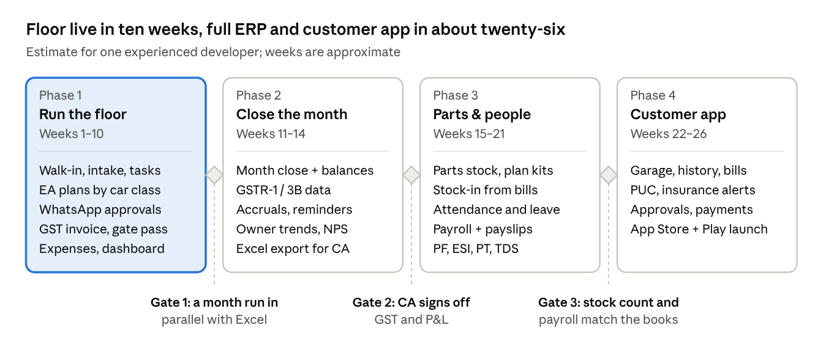
build roadmap · 4 phases, 3 gates
Weeks are estimates for one experienced full-stack developer plus a part-time designer; two developers shorten it by roughly a third. Running costs at one workshop's volume stay small: database, storage and hosting on paid tiers as photos and videos grow (roughly US$25–50 a month, approximate), WhatsApp Business API messages charged per conversation by the provider, payment-gateway fees per transaction, plus the two store accounts.

16. Open decisions
- ☐ Build team: in-house developer, freelancer or agency, and who maintains the system after launch.
- ☐ Plan checklists: finalise the activity points for every plan × car class (incl. Premium Luxury Class 1–3) with N/A, media-required and reading flags.
- ☐ Approval rule: may an advisor approve small add-on work below a set amount on a call, or must every line be approved on WhatsApp.
- ☐ Credit customers: does the owner override of no-pay-no-gate-pass apply to fleets, corporates or insurance jobs.
- ☐ Billing cut-over: date to start issuing invoices from the app, and whether the current invoice series continues.
- ☐ Devices on the floor: technicians' own phones, or a shared phone or tablet per bay.
- ☐ Technician incentives: per plan sold, per job, per activity point, or a % of labour.
- ☐ Payroll compliance: which staff are covered by PF and ESI, and who files challans.
- ☐ Inventory scope: all parts from day one, or oils, filters and plan kits first.
- ☐ History import: October 2026 only, or earlier months and customer history too.
- ☐ Pickup & drop: in-house drivers only, or a pickup charge and third-party drivers.
- ☐ Customer app scope at launch: which of 8.1 ship first (suggested: My garage, live job, approvals, history, bills, reminders, request service).
- ☐ Online payments: which payment gateway, and whether customers may pay before delivery in the app.
- ☐ Insurance renewals: reminders only, or tie up with an insurer or broker to offer renewal quotes.
- ☐ PUC: reminders only, or arrange PUC testing at the workshop as a service.
- ☐ Rewards: referral rewards and loyalty points — values and how they are redeemed.

